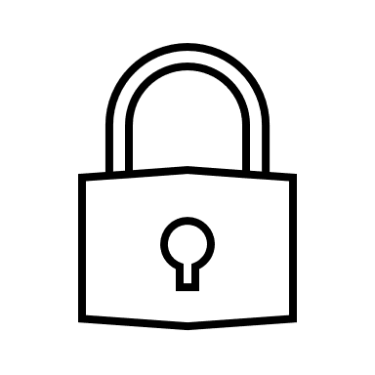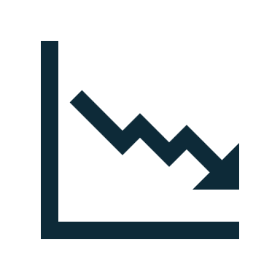

**Our Solution:**  
Software that allows tracking from

Implementation to decommission

Complete Device History

Asset Tracking/ Accountability

Improved Device Efficiency

Reduction in Operation Costs

Improved Security

Reduction in E-Waste

IoT Lifecycle

Manager



**Benefits:**

**Our Mission:**

Providing a seamless, scalable software solution for managing and tracking IoT device lifecycles, ensuring security, trackability, sustainability, and ease of use.

**Your t**